Once done please email with a completed booking form to ethanhanson@southstaffs.ac.uk
LOCATION |  | DATE
ACTIVITY |  |  | TEACHER

WHAT ARE THE HAZARDS | WHO MIGHT BE HARMED AND HOW? | CURRENT RISK RATING | ADDITIONAL CONTROLS REQUIRED  (To include responsibilities and timescales | FUTURE RISK RATING

ASSESSMENT CARRIED OUT BY |  | DATE

COMPLETING THE RISK ASSESSMENT FORM (For further information, see ‘Risk Assessment Form Guidance’)

- Hazards – make a list of all the relevant hazards associated with the task/activity (i.e. anything that has the potential to cause harm).
- Who can be harmed – make a list of ALL categories of people who could be harmed by the hazard and how
- Current controls – list what is currently in place to protect people from the hazards.
- Risk score – using TABLE A, take into account your current control measures and rate each hazard based on the likelihood of injury occurring and the hazard severity.
- Additional controls required - list any additional controls that will further reduce the risk rating score. Ensure responsibilities for tasks and timescales are added
- Residual risk score – re-calculate the risk score after the introduction of the additional controls. Compare the residual risk score with TABLE B and take further action if necessary.

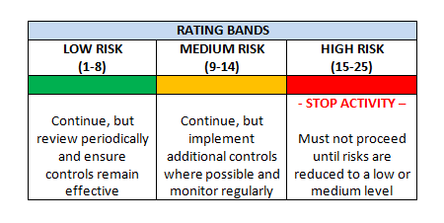
TABLE A TABLE B
HAZARD SEVERITY
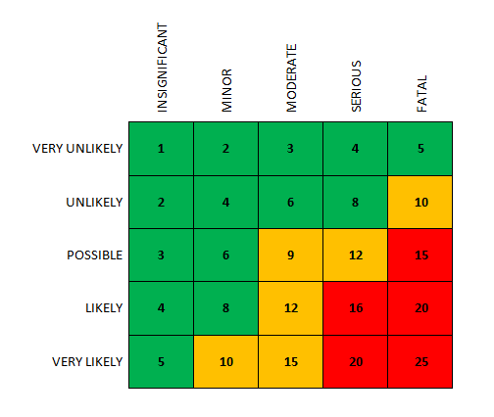

LIKELIHOOD

HAZARD SEVERITY
1 - INSIGNIFICANT (e.g. discomfort, slight bruising)
2 - MINOR (e.g. small cut, abrasion, basic first aid required)
3 - MODERATE (e.g. strain, sprain, and incapacitation > 3 days)
4 - SERIOUS (e.g. fracture, hospitalisation > 24 Hrs, incapacitation > 4 weeks)
5 - FATAL (single or multiple)

LIKELIHOOD
1 – VERY UNLIKELY (almost never)
2 - UNLIKELY (occurs rarely)
3 - POSSIBLE (could occur, but uncommon)
4 - LIKELY (recurrent but not frequent)
5 – VERY LIKELY (occurs frequently)

