Once done please email with a completed booking form to ethanhanson@southstaffs.ac.uk
LOCATION |  | DATE
ACTIVITY |  |  | TEACHER

WHAT ARE THE HAZARDS | WHO MIGHT BE HARMED AND HOW? | CURRENT RISK RATING | ADDITIONAL CONTROLS REQUIRED  (To include responsibilities and timescales | FUTURE RISK RATING
Carrying of heavy equipment from college to learner chosen locations | - Crew  Strains, back injury, knocks or impacts to the body | Medium | - A suitable number of support crew is required to ensure the weight of materials is shared to minimise risks of overloading of an individual.  - Crew who have medical issues which impact on their ability to carry equipment should not partake in such exercise and alternative measures made | Low
Electric shock | - Cast & Crew  Burns or fatality | Medium | - All equipment checked at college for faults or damage.  - Visual inspection of cables and equipment during booking out.  - Keep away from water | Low
Trailing cables | - Cast & Crew  Slips, trips and falls | Medium | - Ensure cables and extension leads are secured using gaffer tape and in a suitable position to minimise impact on activity and those filming or in location area.  - Ensure extension leads are used correctly and fully extended before use, to prevent overheating. | Low
Causing an obstruction | - Cast & Crew  Pushing and shoving resulting in falls and minor impact injuries. | Medium | - Consideration should be made to the position of the crew and the equipment. Ensure obstruction is minimal and that no one is put into harms way as a result of having to navigate around the crew or equipment.  - All crew members to keep a close eye during filming for potential risks that are generated as a result of filming in location. | Low
Equipment cases, bags and coats causing obstacles
Unattended equipment

Fire or smoke

Surrounding Objects
Weather conditions impacting on the activity affecting equipment and those involved in shoot
Trapped fingers or hands
Moving furniture/set pieces
Equipment dropping or falling onto persons
ADD SOME LOCATION DEPENDANT RISKS, AS ALL LOCATIONS HAVE DIFFERENT SORT OF ADDITIONAL RISKS

ASSESSMENT CARRIED OUT BY |  | DATE

COMPLETING THE RISK ASSESSMENT FORM (For further information, see ‘Risk Assessment Form Guidance’)

- Hazards – make a list of all the relevant hazards associated with the task/activity (i.e. anything that has the potential to cause harm).
- Who can be harmed – make a list of ALL categories of people who could be harmed by the hazard and how
- Current controls – list what is currently in place to protect people from the hazards.
- Risk score – using TABLE A, take into account your current control measures and rate each hazard based on the likelihood of injury occurring and the hazard severity.
- Additional controls required - list any additional controls that will further reduce the risk rating score. Ensure responsibilities for tasks and timescales are added
- Residual risk score – re-calculate the risk score after the introduction of the additional controls. Compare the residual risk score with TABLE B and take further action if necessary.

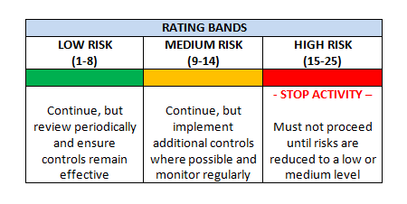
TABLE A TABLE B
HAZARD SEVERITY
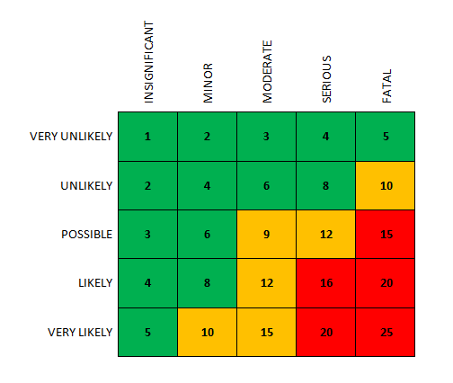

LIKELIHOOD

HAZARD SEVERITY
1 - INSIGNIFICANT (e.g. discomfort, slight bruising)
2 - MINOR (e.g. small cut, abrasion, basic first aid required)
3 - MODERATE (e.g. strain, sprain, and incapacitation > 3 days)
4 - SERIOUS (e.g. fracture, hospitalisation > 24 Hrs, incapacitation > 4 weeks)
5 - FATAL (single or multiple)

LIKELIHOOD
1 – VERY UNLIKELY (almost never)
2 - UNLIKELY (occurs rarely)
3 - POSSIBLE (could occur, but uncommon)
4 - LIKELY (recurrent but not frequent)
5 – VERY LIKELY (occurs frequently)

